Curriculum Vitae

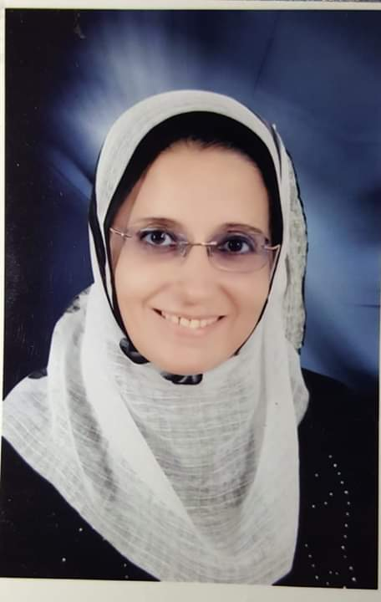
Personal Data:
- Name: Eman Ahmed Fouad Khalil Keshk.
- Date of birth: 8 June 1963.
- Place of birth: Portsaid, Egypt.
- Nationality: Egyptian.
- Address: 38 Borg Mena –Elmahrosa- El Malaha Elgadida - Suez.
- Phone number: 01000180215 – 01288746331.
- E-mail address: tete5500@yahoo.com .
Working Experience:
- 2019 until now: professor of Obstetrics & Gynecology, Faculty of Medicine, Suez Canal University.
- 2014 –2019: Assistant professor of Obstetrics & Gynecology, Faculty of Medicine, Suez Canal University.
- 2014 - 2008: Lecturer of Obstetrics & Gynecology, Faculty of Medicine, Suez Canal University.
- 2008 – 1998: Assistant lecturer of Obstetrics & Gynecology, Faculty of Medicine, Suez Canal University.
- 1998-1995: Demonstrator of Obstetrics & Gynecology, Faculty of Medicine, Suez Canal University.
Education:
April 2008  April 1994  October 1988  September 2013 | - Philosophy of Decorate Degree in Obstetrics & Gynecology, Suez Canal University.  - Master Degree (Very good) in Obstetrics & Gynecology, Suez canal University.  - Bachelor degree (excellent) in medicine, Suez Canal University, Ismailia.  - Diploma in Hospital Management (Very good), Suez Canal University.

Courses:
February 2015 | - Gynecological endoscopic surgery course.
November 2012 | - Center for research & Development in Medical education & Health Services (CRD) A WHO Collaborating Center “How to Write a Scientific Paper” Held at CRD, Faculty of Medicine, Suez Canal University, Ismailia, Egypt.
December 2011 | - International Islamic Centre For Population Studies and Research Assisted Reproduction Unit, Al-Azhar University, (AZHART) in collaboration with International Federation of Gynecology and Obstetrics (FIGO), Reproductive Medicine Committee (RMC) and International Committee for Monitoring Assisted Reproductive Technology (ICMART) “Basic & Advanced Clinical and Laboratory Training Course in infertility including ART for Developing Countries” Cairo, Egypt.
December 2011 | - Regional center For Training (RCT), Department of Obstetrics & Gynecology, Ain Shams University “Training Course in Training of Trainers for “No for FGM” program” Cairo,
October 2010 | - Medical Studies & Research Center “Color Doppler & 4D Ultrasound Pictures of Fetus” New Kaser Al-Aini Specialized Hospital, Cairo, Egypt,

Publications & Supervisions:

Paper Publications | - Effect of a gonadotropin-releasing hormone analogue on cyclophosphamide induced ovarian toxicity in adult mice. Arch Gynecol Obstet (2013) 287(5)1023–1029 DOI 10.1007/s00404-012-2658-y.  - Follicular fluid activin A and leptin are not correlated with IVF outcome measures. Egyptian Fertility & Sterility Society Journal. January 2013, 17 (1) 1:5  - Validity of umbilical artery Doppler waveform versus umbilical vein Doppler waveform in the prediction of neonatal outcome in intrauterine growth restriction cases. Middle East Fertil Soc J (2013), http://dx.doi.org/10.1016/j.mefs.2013.09.005  - Vaginal misoprostol for cervical priming before dilation and curettage procedures on premenopausal and postmenopausal women. Evidence Based Women’s Health Journal 2013, 3:39–44. DOI: 10.1097/01.EBX.0000419640.39654.70  - Female sexual function following different degrees of perineal tears. Int Urogynecol J. 2017 Jun;28(6):917-921.  - Comparison of tamoxifen and clomiphene citrate for induction of ovulation in cases with thin endometrium. Evidenced Based Women Health Journal, November 2018, Vol.8, No. 4, 288-292, DOI: 10.21608/ebwhj.2018.20071.  - Effect of Ginger on relieving of nausea and vomiting during pregnancy. IOSR Journal of Nursing and Health Science (IOSR-JNHS) e-ISSN: 2320–1959.p- ISSN: 2320–1940 Volume 7, Issue 5 Ver. X. (Sep.-Oct .2018), PP 81-92. DOI: 10.9790/1959-0705108192  - Serum concentration of cancer antigen 125 in normal and preeclamptic pregnancies. J. of the Egyptian Society of Gynecology and Obstetrics, June 2019.
Ph.D & master supervision (Most recent) | - Comparing Bipolar Electrocoagulation Versus Intracorporeal suturing on ovarian reserve in Laparoscopic Benign Ovarian Cystectomy.  - Medical versus Surgical Management of Undisturbed Ectopic Pregnancy: Effect on subsequent Ovarian Reserve.  - Use of Metformin versus Chromium Picolinate in the Management of Polycystic ovary syndrome: A Randomized Controlled Clinical Trial.  - Ovarian stimulation after Dehydroepiandrosterone supplementation in Poor Ovarian Reserve.

Computer Skills:
- International Computer Driving License (ICDL) Ver 4.0.
LANGUAGES:
- Arabic: Mother tongue.
- English: Very good, reading and writing (TOEFL).
- French: Good, reading and writing.

